**Mining Product Reviews Based on Shallow Dependency Parsing**

1. INTRODUCTION

In this paper, we study the problem of mining on-line reviews, which consists of identifying product features, identifying expressions of opinions, and discovering relations among them. Shallow dependency parsing segments an input sentence into “phrases” and links the segments with directed arcs. The parsing focuses on the “phrases” and the relations between them, rather than on the single words inside each phrase.

2. THE APPROACH

The approach performs the opinion mining task in three main steps: (1) constructing a shallow dependency tree based on shallow phrase-structure parsing and dependency parsing; (2) extracting candidate product features and candidate opinion expressions; (3) extracting relations between product features and opinion expressions.

Shallow Dependency Parsing

Shallow dependency parsing is dependency parsing with phrase nodes. One phrase is called the *head*, which is the central phrase in the relation, while the other the *dependent*, which modifies the head.

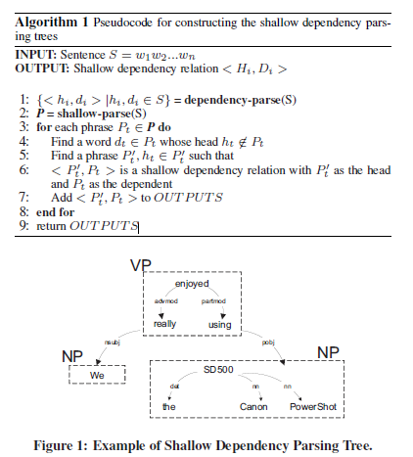

Candidate Product Features and Opinion Expressions Extraction

*Opinion expressions* are spans of text that express an evaluation or attitude of the opinion holder, which are usually evaluative or subjective phrases.

Relation Extraction

The relation extraction is treated as a classification task, and kernel methods is used to address the problem.

3. EXPERIMENTAL RESULTS